Exp. No: 5 Determination and plotting of Electric potential difference between any two points in free space medium separated by a distance R.

Date:
Aim:
To write program for Electric potential difference between two points in free space medium using SCILAB.

Software required:
- SCILAB version 6.0.1

Theory:
Output:
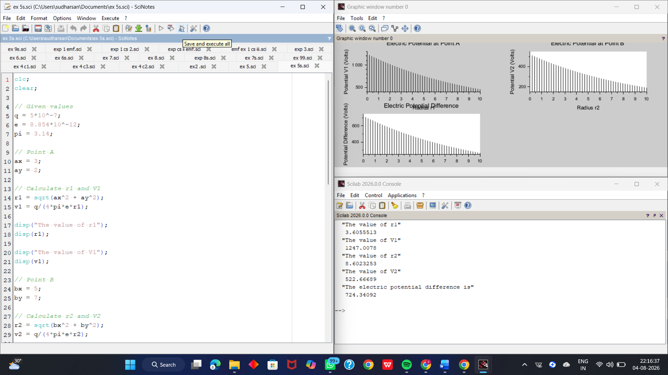

Calcution:
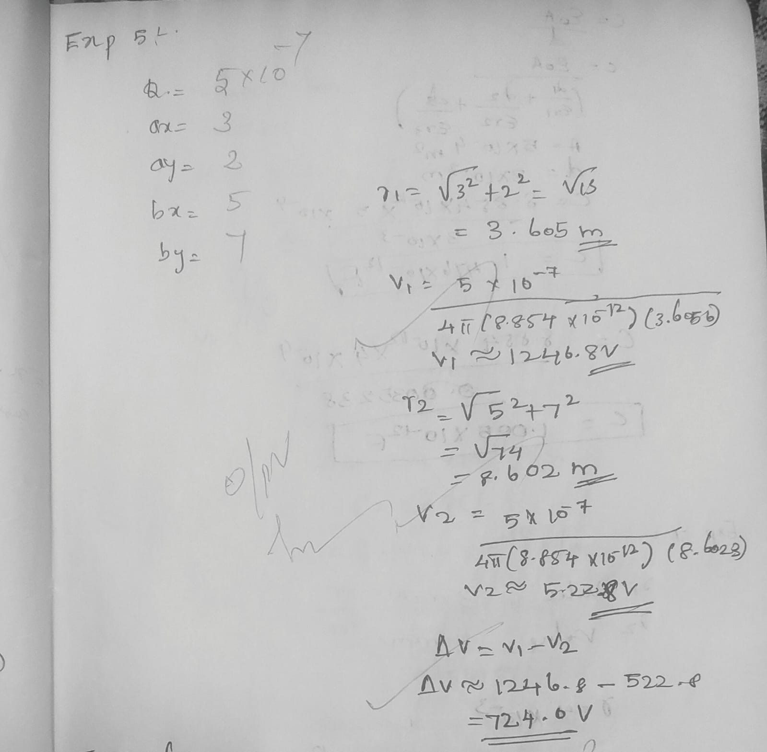

Case 1: A positive charge with fixed r1=1 m r2 varying.
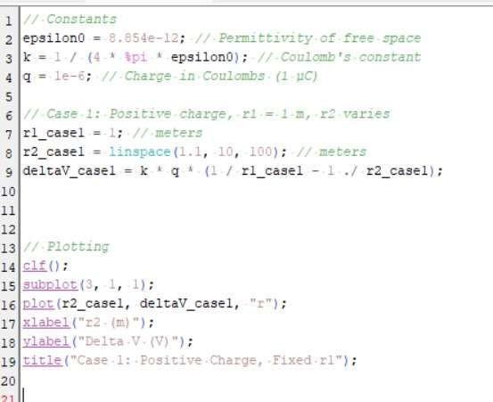

Output:
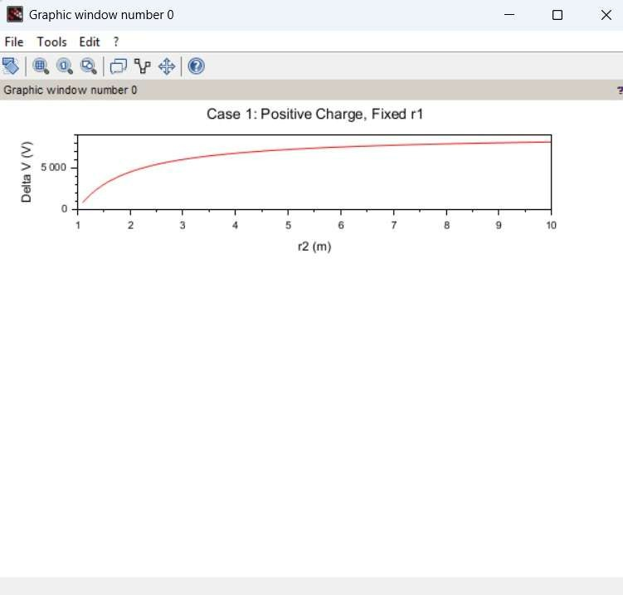
Case 2: A negative charge with r1r_1r1 fixed and r2r_2r2 varying.

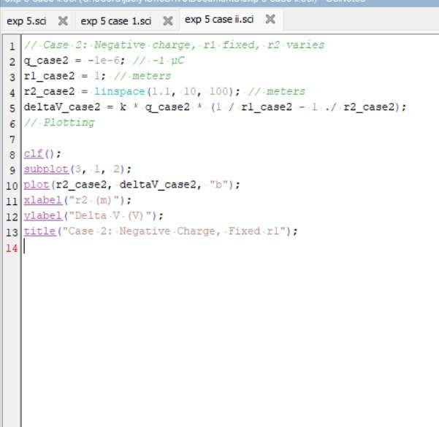

Output:
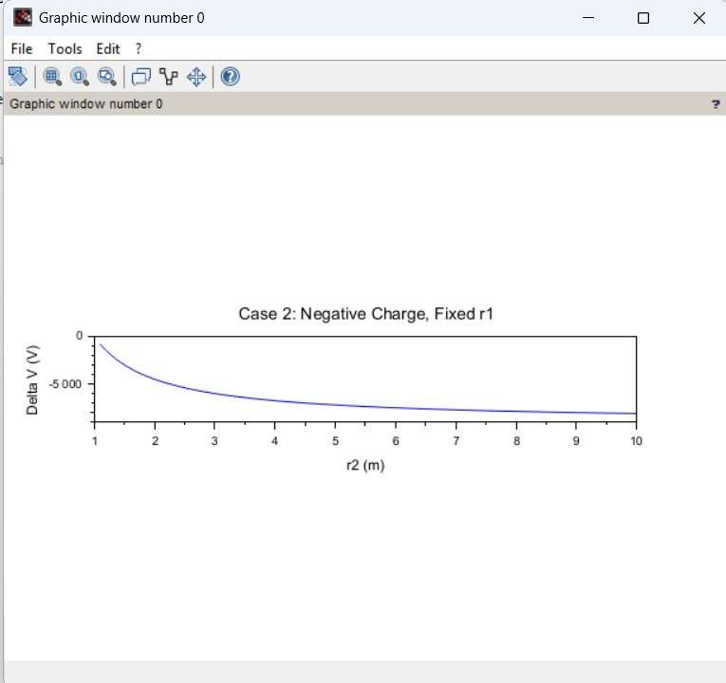

Case 3: Both points r1r_1r1 and r2r_2r2 vary with a positive charge.

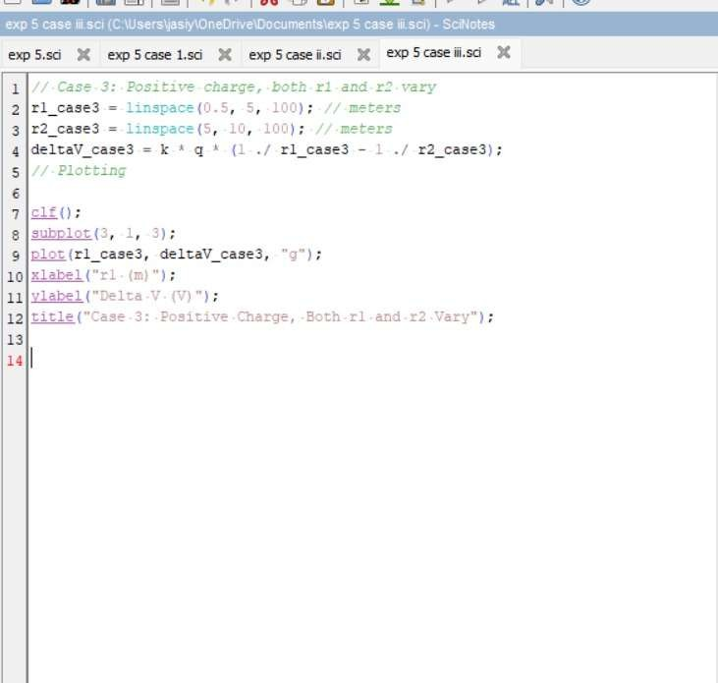

Output:
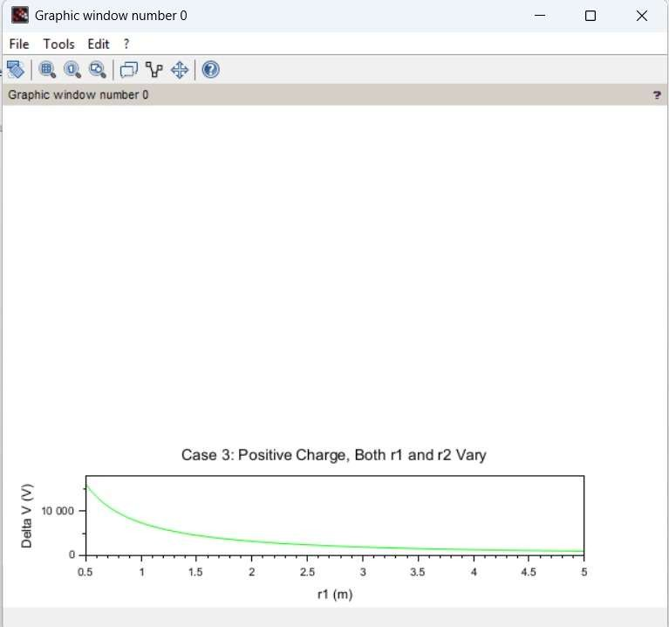

Result :
Thus the program was verified for Electric potential difference between two points in free space medium using SCILAB was successfully.

